# Second Year B. Tech (EL & CE)

**Semester: IV Subject:** Basic IoT

Laboratory

**Name: Shreerang Mhatre Class: SY B.Tech**

**Roll No: 29 Batch: A2**

# Experiment No: 07

**Name of the Experiment**: Interfacing the LCD screen with hardware platforms.

**Performed on: 24/03/2023**

**Teacher’s Signature with date**

|  |
| --- |
| **Marks** |
|  |
|  |

**Submitted on: 10/04/2023**

**Aim:** Interfacing of LCD screen with hardware platforms

**Prerequisite:** Arduino board, Arduino IDE, Basics LCD screen.

# Objectives:

1. To understand usefulness of the LCD screen

# Components and equipment required:

Arduino Uno Board, USB cable, Arduino IDE, LCD screen, 270Ω Resistor, 10 K Potentiometer, Bread board, Jumper wires

# Theory:

LCD means Liquid Crystal Display. We use LCD technology today in watches, digit code display and in TV and advert screens. There exist two big families of LCD displays:

1-Character LCD is based on a matrix of characters (columns x rows). 2- Graphical LCD it is based on a pixel matrix.

We can find many printed circuit boards that include an LCD and the connectors to interface them with Arduino and other systems such that Raspberry pi or PIC microcontroller, nowadays.

There is now a library included in the Arduino Core that is really so easy to use. Its name is **"Liquid Crystal**", and it works with all LCD displays that are compatible with the Hitachi HD44780 driver. This driver is common. Hitachi developed it as a

very dedicated driver, that includes a micro-controller itself, specifically to drive alphanumeric characters LCDs and to connect to the external world easily too, which can be done by a specific link using, usually, 16 connectors, including power supply for the external circuit itself and the backlightsupply too.

These instructions presence in the library of the display:

# #include<LiquidCrystal.h>

* **lcd.begin(16,2):** This instruction use to set up the LCD's number of columns and rows.
* **lcd.print("Message"):** This instruction used for print a message on the LCD if need to display numbers must remove the double quotationmark like this {lcd.print(var)}.
* **lcd.setCursor(j, i):** This instruct used for determine site scripting as row and column where,( j) represent the column and (i) represent the row. The figure below shows us the locations of rows and columns in the 2x16 Liquid Crystal Display. The figure (2.1) below shows the LCD row and column arrangements.
* **lcd.clear( ):** This instruction used to clear the screen .
* **Delay (n):** This instruct used to give delay time where, (n) is an integer number in millisecond. This can used without having to call the library of the screen.

•

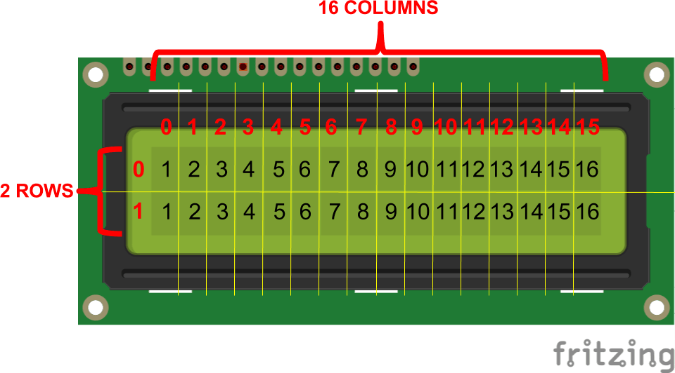

# Fig 7.1

* **LCD pin configuration:**
* The connections of the LCD screen are describe as the following below:
* PIN1 or VSS to ground
* PIN2 or VDD or VCC to +5v power
* PIN3 or VEE to ground (gives maximum contrast best for a beginner)
* PIN4 or RS (Register Selection) to PIN0 of ARDUINO UNO
* PIN5 or RW (Read/Write) to ground (puts LCD in read mode easesthe communication for user)
* PIN6 or E (Enable) to PIN1 of ARDUINO UNO
* PIN11 or D4 to PIN8 of ARDUINO UNO
* PIN12 or D5 to PIN9 of ARDUINO UNO
* PIN13 or D6 to PIN10 of ARDUINO UNO
* PIN14 or D7 to PIN11 of ARDUINO UNO
* PIN 15and 16 for background light.

# Apparatus:

1. Breadboard.
2. ArduinoUNO.
3. Potentiometer 1 KΩ.4- Jumper wires.

5-LCD 2x16.

# Procedure:

1. Connect the circuit shown in fig.7.2 shown below.
2. write Arduino program to display the phrase “System DEP." on the LCD at the First row.
3. Verify the Arduino sketch.
4. Download the Arduino sketch to the Arduino UNO board.
5. Test the circuit and write down the Arduino code on result paper.

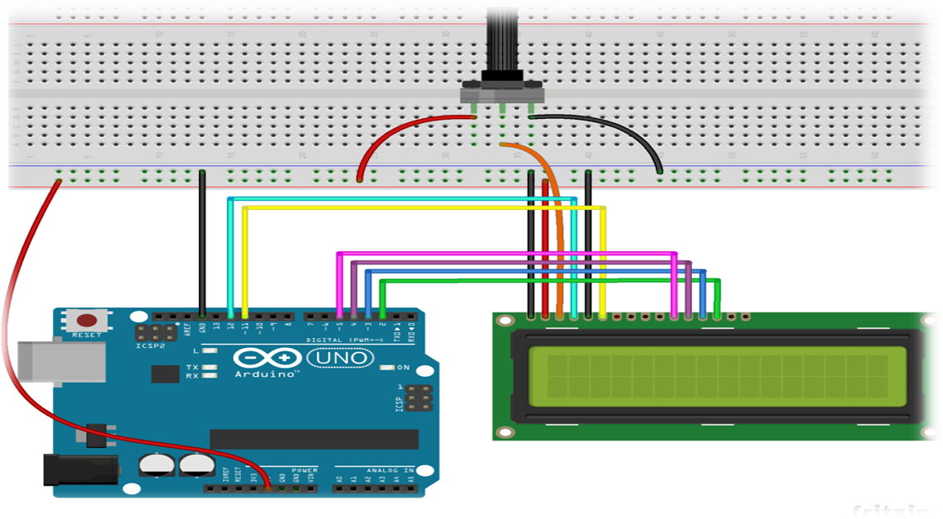

**Figure (7.2) practical circuit diagram**

**Program:**

**Conclusion:**

**Post Lab Questions:**

* 1. What is the benefits of using potentiometer that connected on the pin(3)of the LCD?
  2. Write down the pin configuration of LCD with diagram.

